Assignment submitted on 2020-03-24, 16:27 IST

***1 point***

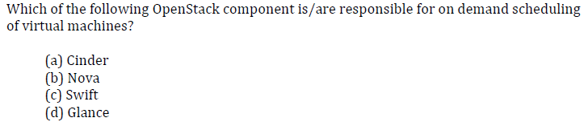

 (a)

 (b)

 (c)

 (d)

Yes, the answer is correct.  
Score: 1

Accepted Answers:

*(b)*

***1 point***

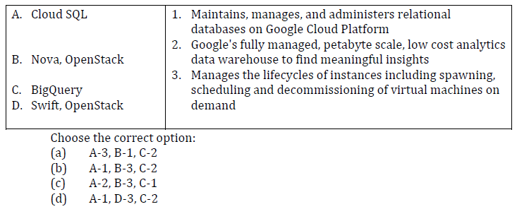

 (a)

 (b)

 (c)

 (d)

Yes, the answer is correct.  
Score: 1

Accepted Answers:

*(b)*

***0 points***

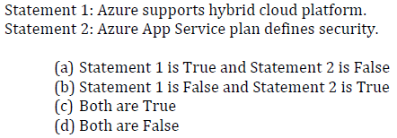

 (a)

 (b)

 (c)

 (d)

No, the answer is incorrect.  
Score: 0

Accepted Answers:

*(d)*

***1 point***

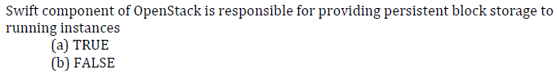

 (a)

 (b)

Yes, the answer is correct.  
Score: 1

Accepted Answers:

*(b)*

***1 point***

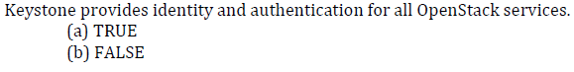

 (a)

 (b)

Yes, the answer is correct.  
Score: 1

Accepted Answers:

*(a)*

***1 point***

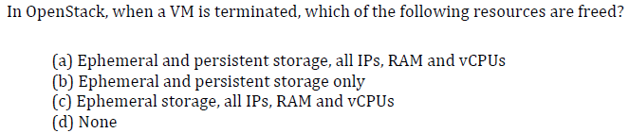

 (a)

 (b)

 (c)

 (d)

Yes, the answer is correct.  
Score: 1

Accepted Answers:

*(c)*

***1 point***

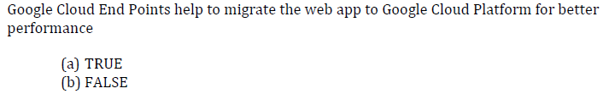

 (a)

 (b)

Yes, the answer is correct.  
Score: 1

Accepted Answers:

*(b)*

***1 point***

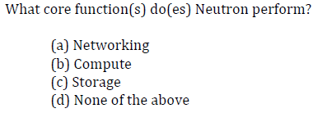

 (a)

 (b)

 (c)

 (d)

Yes, the answer is correct.  
Score: 1

Accepted Answers:

*(a)*

***1 point***

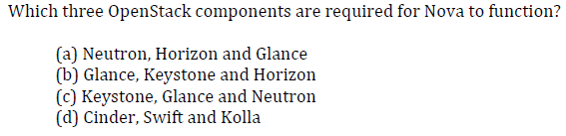

 (a)

 (b)

 (c)

 (d)

Yes, the answer is correct.  
Score: 1

Accepted Answers:

*(c)*

***1 point***

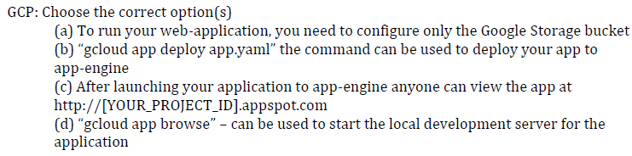

 (a)

 (b)

 (c)

 (d)

Partially Correct.  
Score: 0.5

Accepted Answers:

*(b)*

*(c)*